Amir Hammoud

Nhan Vo

Setha Proeung

CECS 323-06

**RA Inner Join**

1. List the customer name of any customer located in a different state from the office where their sales representative works. This relational algebra tool does not support a coalesce function, but it also seems to be fine with comparing nulls to other values. List the customers in ascending order by customer name. (58)

τ customername π customername σcustomers.state≠Offices.state ∨ customers.country ≠ Offices.country (customers ⨝ salesRepEmployeeNumber = employeeNumber Employees ⨝ Offices.officeCode = Employees.officeCode Offices)

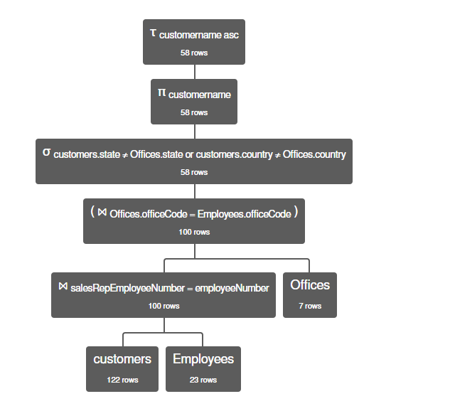

2. List the customers who have ever purchased the ‘Pont Yacht’ product. Be sure to list each customer only once. List the customers in ascending order by customer name. (24)

τ customername πcustomername σ products.productName like '%Pont Yacht%' (customers ⨝ customers.customerNumber = orders.customerNumber orders ⨝ orders.orderNumber = OrderDetails.orderNumber OrderDetails ⨝ OrderDetails.productCode = products.productCode products)

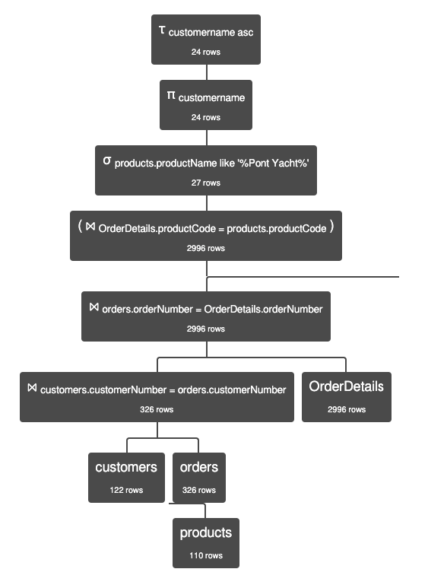

3. List the office code, city, state, and country of every office that has an employee working there who is the sales representative for a customer who has ever bought '1928 Mercedes-Benz SSK'. Order by office code. (5)

τ officeCode π Offices.officeCode, Offices.city,Offices.state,Offices.country σ products.productName like '%1928 Mercedes-Benz SSK%' (Offices ⨝ Offices.officeCode = Employees.officeCode Employees ⨝ Employees.employeeNumber = customers.salesRepEmployeeNumber customers ⨝ customers.customerNumber = orders.customerNumber orders ⨝ orders.orderNumber = OrderDetails.orderNumber OrderDetails ⨝ OrderDetails.productCode = products.productCode products)

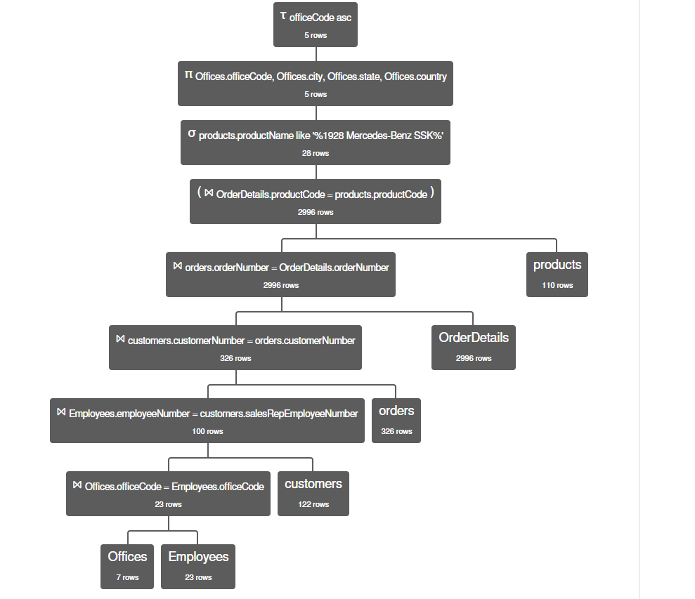

4. Select customer name, order date, shipped date, quantity ordered, product line, product name for all orders made in May of 2013 and shipped in some other month. Order by customer name and order date (17)

τ customers.customername, orders.orderDate (σ month(orderDate) = 5 ∧ year(orderDate) = 2013 ∧ month(orderDate) ≠ month(ShippedDate) (π customers.customername, orders.orderDate, orders.ShippedDate, OrderDetails.quantityOrdered, products.productLine, products.productName ((customers) ⨝ customers.customerNumber = orders.customerNumber (orders) ⨝ orders.orderNumber = OrderDetails.orderNumber (OrderDetails) ⨝ OrderDetails.productCode = products.productCode (products))))

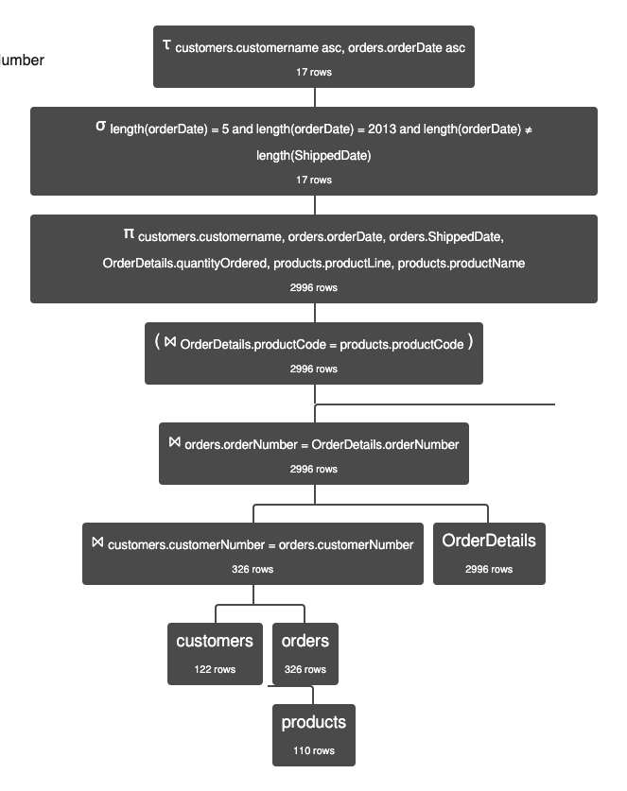

5. Select customer name, order number, order date, and status on all orders in which at least one of the products ordered has a quantity ordered > the quantity in stock for that product. List each order no more than once. Order by the customer name and the order number. (28)

τ customers.customername, orders.orderNumber π customers.customername, orders.orderNumber, orders.orderDate, orders.status σ OrderDetails.quantityOrdered > products.quantityInStock (customers ⨝ customers.customerNumber = orders.customerNumber orders ⨝ orders.orderNumber = OrderDetails.orderNumber OrderDetails ⨝ OrderDetails.productCode = products.productCode products)

